LAIBA FAISAL

213002

LAB REPRORT

LAB 5

Q1: The function islower, shown in Figure 5.1, tests whether a character **ch**  is lowercase or not. Write the main function of a program that reads a character ch, calls the function islower, and then prints a message to indicate whether ch is a owercase character or not.

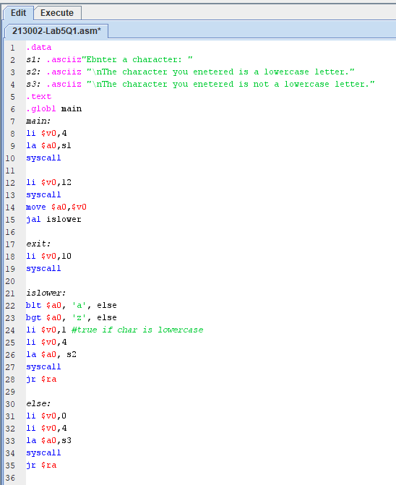

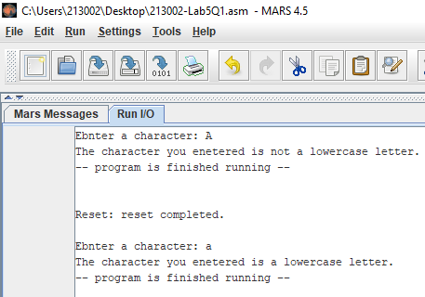

Q2: Write a function that reads an array of n integers. The function read must receive two arguments:

$a0 = address of the array

$a1 = number n of elements to read.

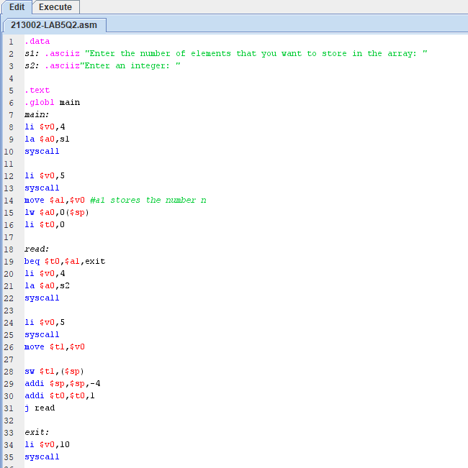

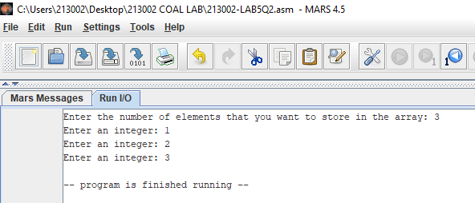

Q3:

Write a function that prints an array of n integers. The function print must receive two arguments:

$a0 = address of the array

$a1 = number of n elements to print

Lab 6

Q1:

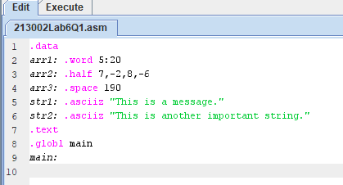

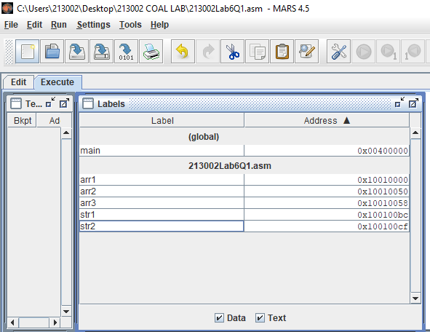

Q2:

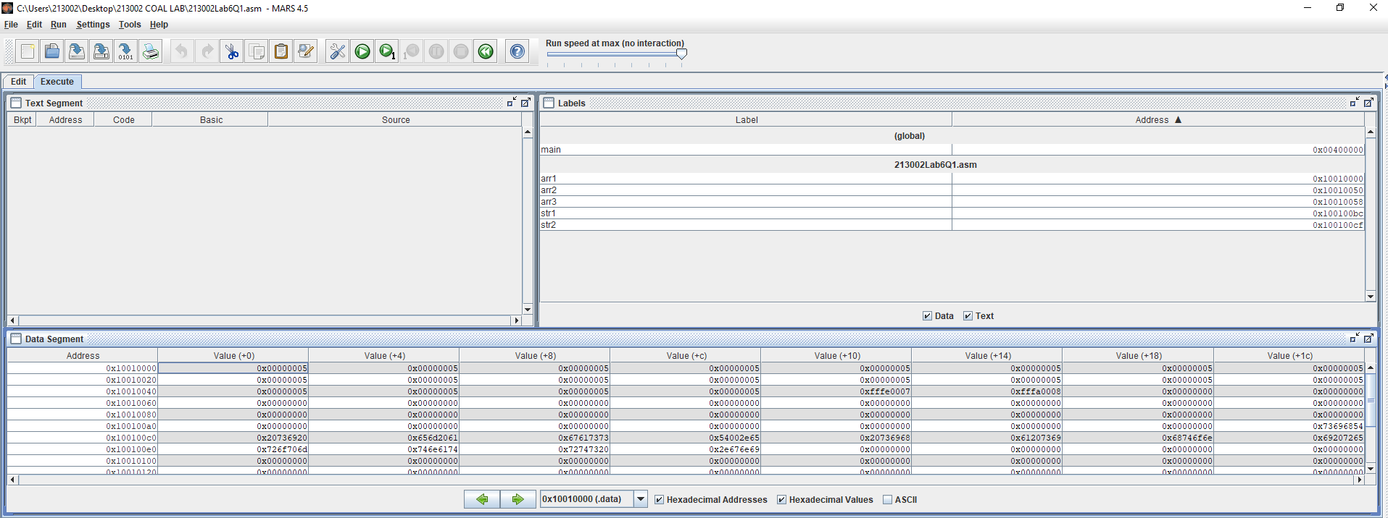

Address of arr1 = 0x10010000

Address of arr1[5] = 0x10010000 + (32*5)

= 0x10010000 + 160

=

Q3:

Write a MIPS program that defines a one-dimensional array of 10 integers in the static area of the data segment, ask the user to input all 10 array elements, computes and displays their sum.

**EXAMPLE 6.4.1**

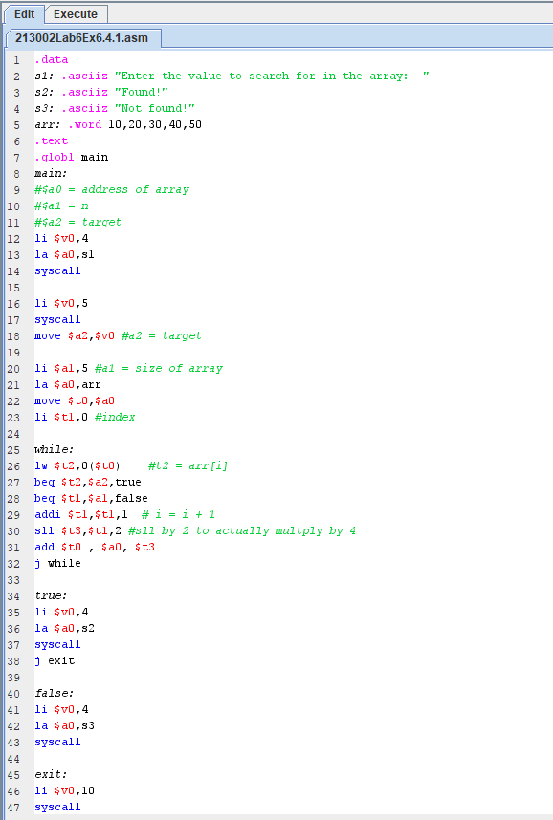

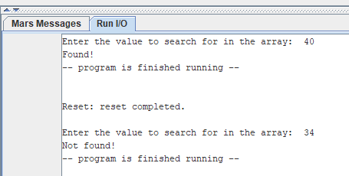

**EXAMPLE 6.4.2:**

**EXAMPLE 6.5:**

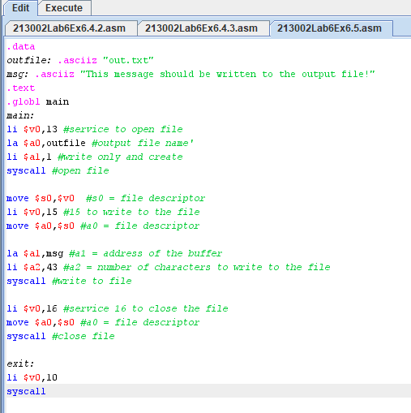

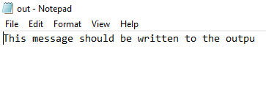

**LAB 7:**

**Example 1:**

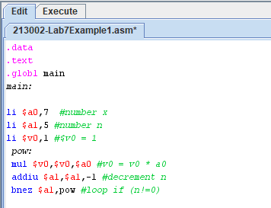

Q1: Write MIPS code to perform the following integer multiplications. What is the value of the **LO** and **HI** registers?

1. 98765 x 54321 using the **multu** instruction
2. -98765 x (-54321) using the **mult** instruction.

a):

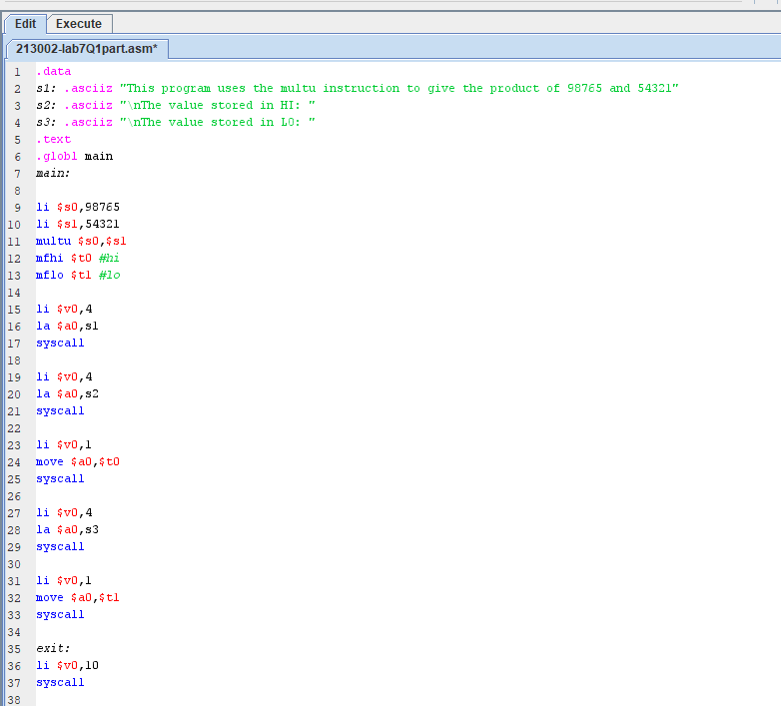

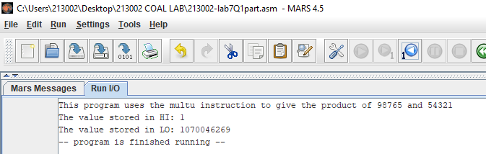

The value in **HI** in hexadecimal: 0x00000001

The value in **LO** in hexadecimal: 0x3fc79c3d



(b)

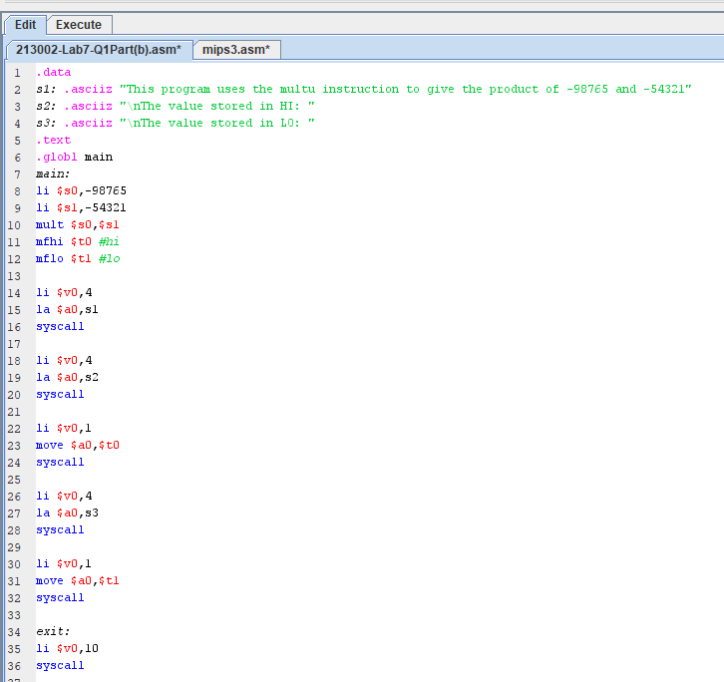

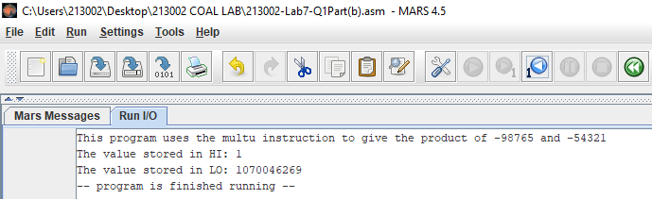

The value in **HI** in hexadecimal: 0x00000001

The value in **LO** in hexadecimal: 0x3fc79c3d

Q3: Factorial calculation: Using the **mul** instruction, write a MIPS program that computes the factorial of a number **n** input by the user, and display the result on the screen. Run your code and record the maximum 32-bit factorial value that can be computed without errors.

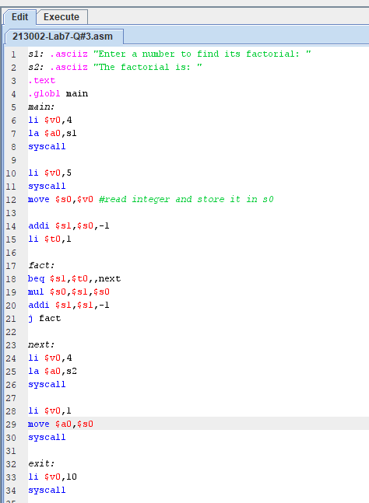

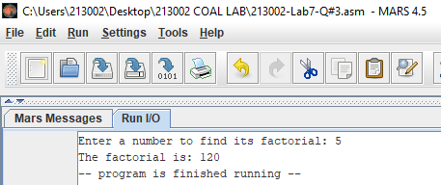

LAB 7 :

EXAMPLE 1: **GCD**

CODE:

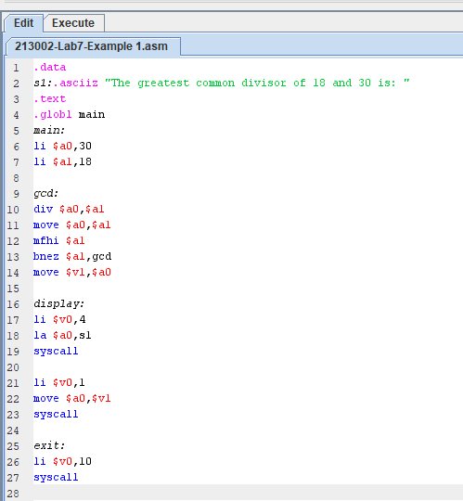

OUTPUT:

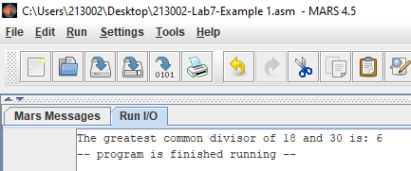

Example 2:

Code:

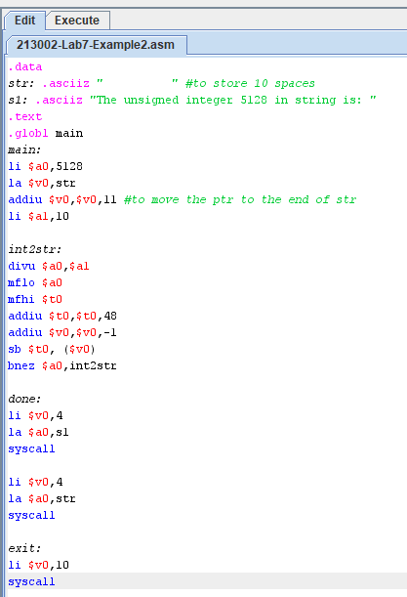

Output:

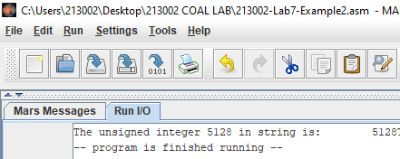

EXAMPLE 3:

CODE:

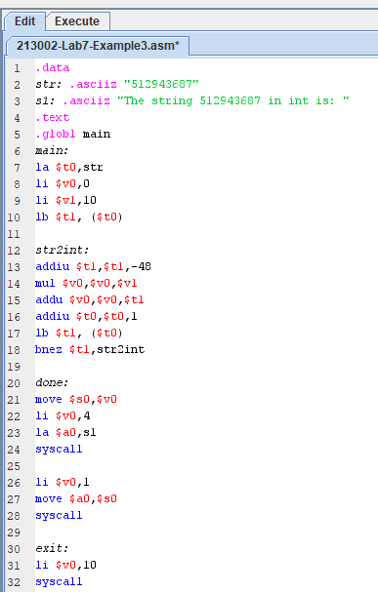

OUTPUT:

